Name: Mohammed Jaorawala SYECS1-65

EXPERIMENT NO:7
Date of Performance: | 15/10/2026
Date of Submission: | 15/10/2026

Experiment No:7
DETECT A COMPANY LOGO ON PRODUCT PACKAGING IN A STORE SHELF IMAGE SYSTEMS
  - Aim: To Detect a company logo on product packaging in a store shelf image systems

  - Course Outcome: Analyze visual data using image processing algorithms to recognize objects and their shapes.
  - Learning Objectives: Analyze the limitations and challenges associated with Template Matching and explore possible solutions or improvements.

  - Requirement: MATLAB

Related Theory:

Template matching two techniques are there
    - Performance Index Method.
    - Normalized Cross Correlation method.

It is a technique which is used to recognize whether a given part
belongs to a particular class of or not. All the parts which belong to a particular class of parts are kept in front of the camera one by one at a time, their images are obtained digitized & stored in a library of parts in memory as templates Ti (k,j) of size (mo x no). Now the class of parts (scene) captured by the camera image is digitized & is given by I(k j) of size (m X n) and stored in the memory.

Now in the memory there are a number of templatesTi (k j) and one image I (k,j). To search whether a given part (template) belongs to the class of parts (image) or not take the

template & scan the gray scale image or digital image I (k , j) from left to right & top to bottom using a raster scanning method.
At each time of translation obtain & index performance is called as performance index Pi(x,y).
Whenever the template matches with the part in the image, the index=0. The match has been filmed and the search is successful. The location of the part is also found. The performance index is given by
Pi(x,y)= ^{Mo}Σ ^{no}Σ I(k=x,j+y)-Ti(k,j) k=1 j=1

Procedure:
    - set I=1,x=0,y=0,e>0
    - compute Pi(x,y)
    - set y=y+1;if y<=(n-n0) go to step 2
    - set y=0,x=x+1,if x<=(m-m0) go to step2
    - set found =false.

Program and Output:

Code:
%% DETECT A COMPANY LOGO ON PRODUCT PACKAGING IN A STORE SHELF IMAGE
% Method 1 : Performance Index (sum of absolute differences) - as per procedure
% Method 2 : Normalized Cross Correlation (NCC)
%
% Files needed in the same folder (change names below):
% shelf.jpg -> store shelf image (scene I)
% logo.png -> company logo image (template T)
% Toolbox needed: Image Processing Toolbox (only for NCC / normxcorr2) clc; clear; close all;
%% 1. READ IMAGES
sceneFile = 'shelf.jpg'; logoFile = 'logo.jpg';
I_rgb = imread(sceneFile); T_rgb = imread(logoFile);
% Convert to gray scale
if size(I_rgb,3) == 3, I = rgb2gray(I_rgb); else, I = I_rgb; end
if size(T_rgb,3) == 3, T = rgb2gray(T_rgb); else, T = T_rgb; end

% Optional: shrink both images to speed up the raster scan
% (the raster scan with loops is slow on big images) scale = 0.5; % set 1 for no resizing
I = imresize(I, scale); T = imresize(T, scale);

I = double(I); T = double(T);

[m, n ] = size(I); % scene size (m x n)
[mo, no] = size(T); % template size (mo x no)
fprintf('Scene size : %d x %d\n', m, n); fprintf('Template size : %d x %d\n', mo, no);
%% =====================================================
% METHOD 1 : PERFORMANCE INDEX METHOD
% Pi(x,y) = sum_k sum_j | I(k+x, j+y) - T(k,j) |
% Perfect match -> Pi = 0
% =====================================================

% Step 1 : initialise x = 0; y = 0;
e = 0.12; % threshold (tolerance). Real images never give exactly 0
% so we accept a match if normalized Pi <= e
found = false; bestPi = inf; bestXY = [0 0];
PI_map = nan(m-mo+1, n-no+1); % store Pi at every position

tic;
while x <= (m - mo) % Step 4 : move down y = 0;
while y <= (n - no) % Step 3 : move right
% Step 2 : compute performance index at (x,y) patch = I(x+1 : x+mo, y+1 : y+no);
Pi = sum(sum(abs(patch - T)));

% Normalize so that e is independent of image / logo size
% (0 = perfect match, 1 = worst possible) Pi_norm = Pi / (mo * no * 255);

PI_map(x+1, y+1) = Pi_norm; if Pi_norm < bestPi

bestPi = Pi_norm; bestXY = [x y];
end
y = y + 1; end
x = x + 1; end
t1 = toc;

% Step 5 : decision if bestPi <= e
found = true; end
fprintf('\n--- Performance Index Method ---\n'); fprintf('Minimum Pi (normalized) = %.4f\n', bestPi); fprintf('Time taken = %.2f s\n', t1);
if found
fprintf('LOGO FOUND at row = %d, column = %d\n', bestXY(1), bestXY(2)); else
fprintf('LOGO NOT FOUND (min Pi > threshold e = %.2f)\n', e); end

%% =====================================================
% METHOD 2 : NORMALIZED CROSS CORRELATION
% =====================================================
tic;
C = normxcorr2(T, I); % size (m+mo-1) x (n+no-1) t2 = toc;
[maxC, idx] = max(C(:));
[ypeak, xpeak] = ind2sub(size(C), idx);

% Convert peak position to top-left corner of the matched region row_ncc = ypeak - mo + 1;
col_ncc = xpeak - no + 1;

nccThreshold = 0.70; % NCC close to 1 = good match fprintf('\n--- Normalized Cross Correlation ---\n');
fprintf('Max correlation = %.4f\n', maxC); fprintf('Time taken = %.4f s\n', t2);
if maxC >= nccThreshold
fprintf('LOGO FOUND at row = %d, column = %d\n', row_ncc, col_ncc); else
fprintf('LOGO NOT FOUND (max NCC < %.2f)\n', nccThreshold); end

%% =====================================================
% DISPLAY RESULTS
% =====================================================
Idisp = uint8(I);
figure('Name','Logo Detection','NumberTitle','off'); subplot(2,2,1); imshow(uint8(T)); title('Template (Logo)'); subplot(2,2,2); imshow(Idisp); title('Shelf Image (Scene)'); subplot(2,2,3); imshow(Idisp); hold on;
title('Performance Index Result'); if found
rectangle('Position', [bestXY(2)+1, bestXY(1)+1, no, mo], ... 'EdgeColor','g','LineWidth',2);
text(bestXY(2)+1, max(bestXY(1)-8,5), 'Logo found', ...
'Color','g','FontWeight','bold');
else
text(10, 20, 'Logo not found', 'Color','r','FontWeight','bold'); end

subplot(2,2,4); imshow(Idisp); hold on; title('NCC Result');
if maxC >= nccThreshold
rectangle('Position', [col_ncc, row_ncc, no, mo], ... 'EdgeColor','r','LineWidth',2);
text(col_ncc, max(row_ncc-8,5), 'Logo found', ... 'Color','r','FontWeight','bold');
else
text(10, 20, 'Logo not found', 'Color','r','FontWeight','bold'); end

% Performance index map (dark spot = best match) figure('Name','Performance Index Map','NumberTitle','off'); imagesc(PI_map); colormap(jet); colorbar; title('Performance Index Pi(x,y) (minimum = best match)'); xlabel('y (column shift)'); ylabel('x (row shift)');

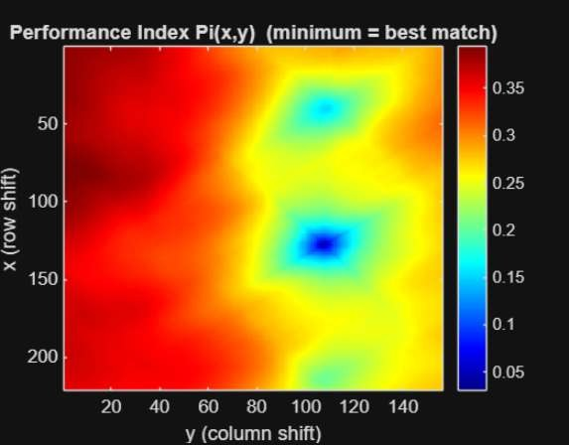
Output:
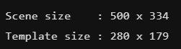
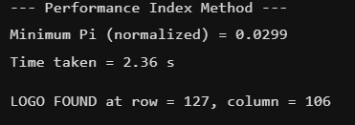
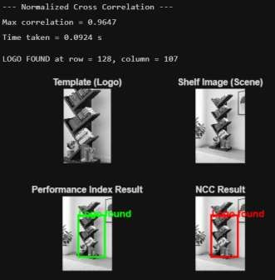

Conclusion:
Template Matching even though it’s a simple technique, one limitation is that the two images being compared should have the same average intensities

